EXPERIMENT PHASES AND RESULTS REPORT
-Nitin Kumar
Idea:
The main idea/objective of the research is to create a system that will 3 major tasks
- Analyze the soil moisture level.
- Identify the type of insect nearby using their sound.
- Send these data to an application such as Krishi Mapper
To accomplish these tasks, we started by creating a blueprint of the workflow of each module in the system, which is given below.
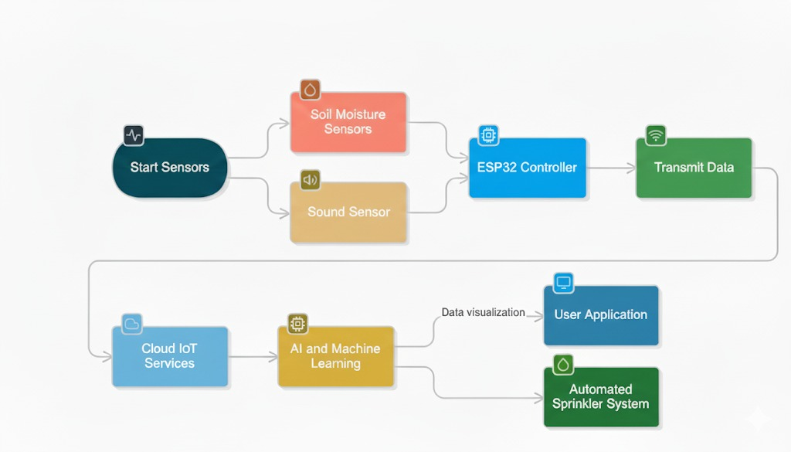
Figure 1: Work flow prototype
Explanation of the workflow prototype:
Each module in the system will consist of 2 major sensor types: one for soil moisture sensing and another for insect sound detection. All these sensors will be connected to a controller (e.g., ESP32), which will send the data to cloud servers via Wi-Fi/internet. In the cloud, we will run our Fine-Tuned AI Model to analyse and classify insect species. This data will be sent to the mobile application (such as Krishi mapper), with that information, users can take actions like deciding the pesticides to use / water management plans, etc.
Optionally, the system can also trigger an automated system, such as for sprinkling water in the area that has low moisture content.

Then, to get a reasonable standard of accuracy, we took 1acre of land as an example and divided it into 5 points (p1-p5). We often would use data from the place with different depths (eg,10cm,20cm,30 cm). (referenced: Minimum number of TDR sensors needed for a reasonable standard of accuracy by Lincoln Zotarelli, Michael D.Dukes, and Marcelo Paranhos). The collective data of these different depths will be 1 point. To achieve a reasonable amount of accuracy, we will need at least a 5-point system. 1acre = 4046.86 m² i.e, ~4047 m² . Therefore, 4047/5 = 809.4m² or~28.44 m. Therefore, a 5-point system will need to be placed with a special distance of ~28.44m between each other.

Figure 2:The 5-point system
Then we started to create the architectural layout for the prototype of each module (P_{n}), which includes all the sensors and other parts needed to collect and send the data, which was:
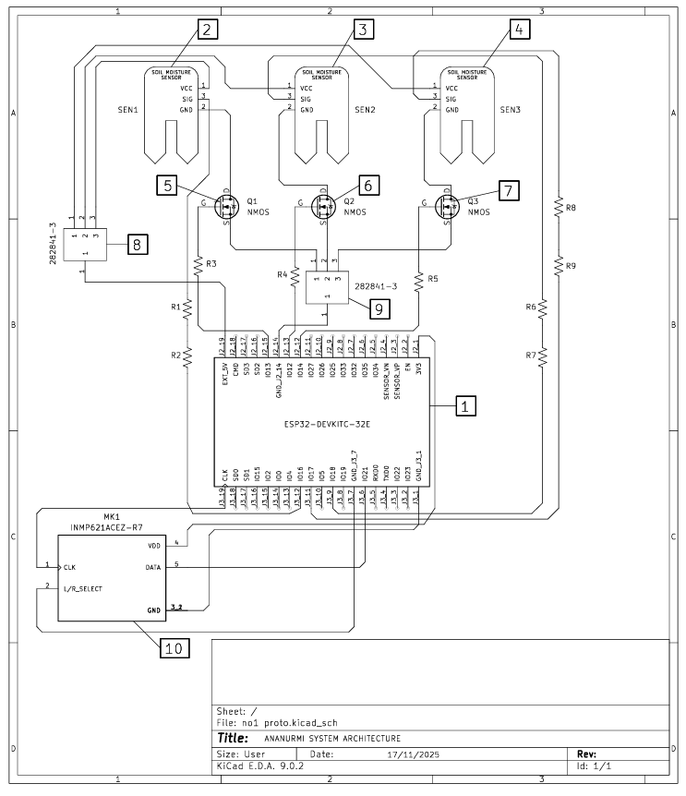
Figure 3 Module Architecture
Explanation of the architectural design
This section details the individual components comprising the developed system, outlining their specific functions and contributions to the overall architecture. Each marked component from Figure 3 is described below.
1. ESP32-DEVKITC-32E (Microcontroller Unit)
The ESP32-DEVKITC-32E serves as the central processing unit of the system. This powerful, low-cost, and low-power System-on-Chip (SoC) integrates Wi-Fi and dual-mode Bluetooth capabilities, making it ideal for IoT applications. Its primary functions within this system include:
Sensor Data Acquisition: Interfacing with and precisely reading data from the multiple soil moisture sensors [2,3,4] and The Microphone [10].
Data Processing: Executing embedded algorithms and logic to process incoming sensor data, enabling environmental monitoring and decision-making.
Power Management: Controlling the power supply to peripheral components, such as the soil moisture sensors, via N-Channel MOSFETs [5,6,7]to optimize power consumption and extend system longevity.
Communication: Facilitating data transmission and remote monitoring through its integrated wireless communication modules.

2. Soil Moisture Sensor 1 [2]
This is the first of three distributed soil moisture sensors integrated into the system.
Function: Measures the volumetric water content of the soil at its specific location by assessing the soil's dielectric permittivity. These are typically capacitive sensors.
Application: Provides crucial localized data for environmental monitoring, allowing the ESP32 [1] to infer the hydration status of a particular soil segment.

3. Soil Moisture Sensor 2 [3]
The second soil moisture sensor, deployed independently to gather additional localized moisture data.
Function: Operates identically to [2], providing distinct moisture readings from a separate area.
Application: Enhances the spatial resolution of soil moisture mapping, contributing to a more comprehensive understanding of moisture distribution across the monitored area.

4. Soil Moisture Sensor 3 [4]
The third and final dedicated soil moisture sensor in the array.
Function: Delivers a third data point on soil moisture content, mirroring the operational principles of [2] and [3].
Application: Further refines the system's ability to identify variations in soil hydration.

5. Q1 NMOS (N-Channel MOSFET)[5]
An N-Channel Metal-Oxide-Semiconductor Field-Effect Transistor, configured as an electronic switch.
Function: Controlled by a digital output from the ESP32 [1], this MOSFET acts as a switch to regulate the power supply to Soil Moisture Sensor 1 [2].
Application: Implements power-saving strategies by allowing the ESP32 [1] to only energize [2] when a reading is actively required, thereby minimizing continuous current draw and extending battery life, particularly in energy-constrained deployments.

6. Q2 NMOS (N-Channel MOSFET)[6]
Functionally identical to Q1 [5], this N-Channel MOSFET controls the power supply to Soil Moisture Sensor 2 [3].
Function: Enables the ESP32[1] to switch the power rail for [3] on or off.
Application: Contributes to the overall power management strategy by ensuring [3] is only active during data acquisition cycles.

7. Q3 NMOS (N-Channel MOSFET)[7]
Another N-Channel MOSFET, paralleling the function of Q1[5] and Q2[6], dedicated to managing the power for Soil Moisture Sensor 3 [4].
Function: Facilitates controlled power delivery to [4] under the command of the ESP32 [1].
Application: Completes the distributed power management scheme for the soil moisture sensor array, optimizing energy consumption across all sensing nodes.

8. Q1 Wire Splitter [8]
Function: Splitter 1 input line to 3 output lines
Application: used to provide power to [2][3][4] from the ESP32[1]

9.Q2 Wire Splitter[9]
Function: Splitter 3 outputs lines to 1 input line
Application: used to Ground all three soil moisture sensors [2][3][4]

10. MK1 INMP621ACEZ-R7
This component is a high-performance, low-power, digital-output, omnidirectional MEMS (Micro-Electro-Mechanical-Systems) microphone.
Function: Its primary role is to capture acoustic signals from the environment and convert them into a digital data stream.
Application: Recording ambient sounds in the deployment area

Then, we started the main process of Data collection and Patterns identification for this system. We were able to collect audio data of 17 different species of cicadas, including :
- Azanicadazuluensis
- Brevisianabrevis
- Kikihiamuta
- Myopsaltaleona
- Myopsaltalongicauda
- Myopsaltamackinlayi
- Myopsaltamelanobasis
- Myopsaltaxerograsidia
- Platypleuracapensis
- Platypleuracfcatenata
- Platypleurachalybaea
- Platypleuradeusta
- Platypleuradivisa
- Platypleurahaglundi
- Platypleurahirtipennis
- Platypleuraintercapedinis
- Platypleuraplumosa
From the following websites:
- Zenodo.org
- Arxiv.org
Experimentation Process:
To extract the data from the audio, we 3 signal representation domains:
- Time-Domain
- Frequency Domain
- Time-Frequency Domain
Here, each Domain was split into separate phases of experimentation
Phase 1 (Time-Domain)
Methods Used: Amplitude envelop, RMS (root mean square), Zero crossing Rate
- Amplitude envelope:
Here, we took the audio wave for time t (which was 5 seconds for each audio) at a sample rate of 22050 or 22 kHz overall. Then we divided the wave into frames of size 1024, with 50% overlap for a smoother curve. Then we took the maximum amplitude in each frame and plotted it.
The function below shows how we calculate the amplitude envelope for all the species.
#amplitude envelop
def audio_env(signal,frame_size,hop_size):
audio_env=[]
for i in range(0,len(signal),hop_size):
audio_env.append(max(signal[i:frame_size+i]))
return audio_env

RESULTS: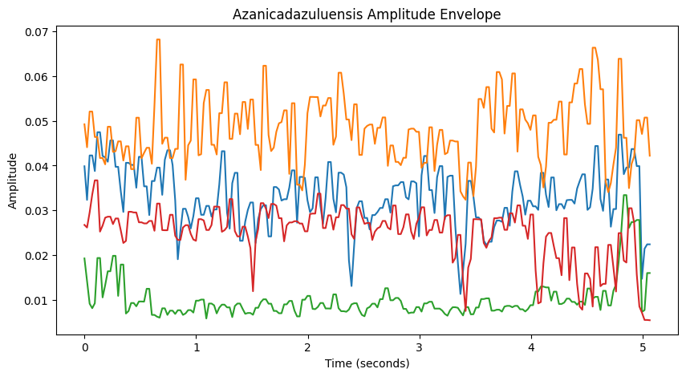
Figure 4: Amplitude Envelope of 4 Azanicadazuluensis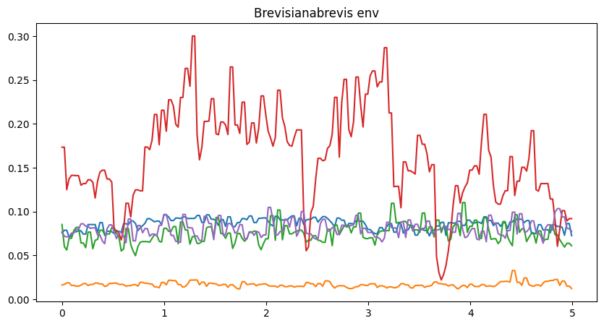
Figure 5:Amplitude Envelop of 5 Brevisianabrevis

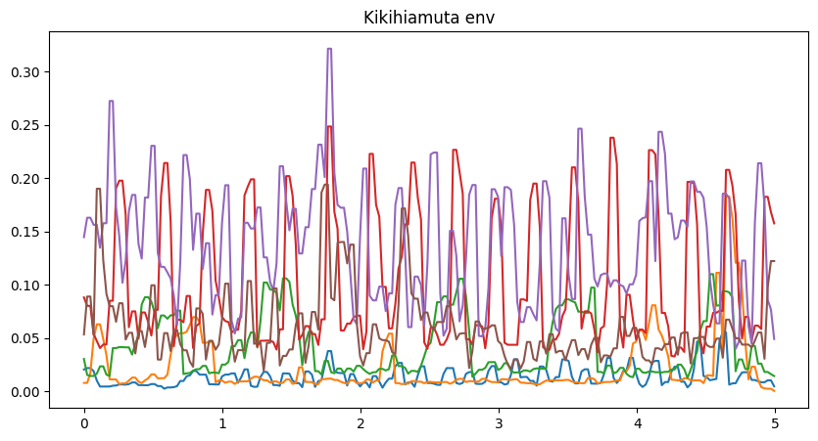
Figure 6:Amplitude Envelope of 6 Kikihiamuta
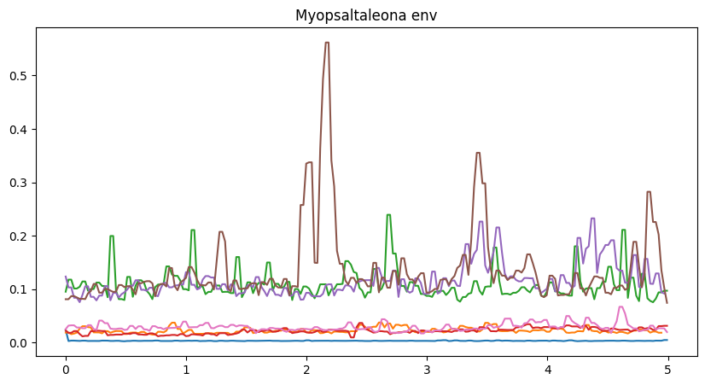
Figure 7: Amplitude Envelope of 7 Myopsaltaleona

Note: Please check the attached file for all the Results of the amplitude envelope and all other Results
AS we can see from the above given Plots, the Amplitude envelopes of the data were messy and hard to identify any particular pattern; therefore, pattern identification using amplitude envelopes was unsuccessful.

- RMS (root mean square):
RMS (Root Mean Square) is a measurement of the average power or loudness of a signal within a frame.
Mathematically:
RMS = $\sqrt{\frac{1}{N}\sum_{k=0}^{N-1}{s{\left(k\right)}^{2}}}$
Where:
- s(k) = kth sample inside the frame
- N = number of samples in the frame
Or in our case
RMS = $\sqrt{\frac{1}{1024}\sum_{k=0}^{1023}{s{\left(k\right)}^{2}}}$

The code segment below shows how we calculate the amplitude envelope for all the species. Using the Librosa Package. (The dictionary audio_data has the loaded audio data with the species name as its Key)
#rms
audio_envelop_single_species={}
for index,i in enumerate(audio_data.keys()):
audio=[]
for j in audio_data[i]:
y=librosa.feature.rms(y=j)
audio.append(y)
audio_envelop_single_species[i]=audio
for index,i in enumerate(audio_envelop_single_species.keys()):
for j in audio_envelop_single_species[i]:
j=j.flatten()
t=librosa.core.frames_to_time(range(len(j)),hop_length=512)
plt.plot(t,j)
plt.title("speciesname_rms")

RESULTS:
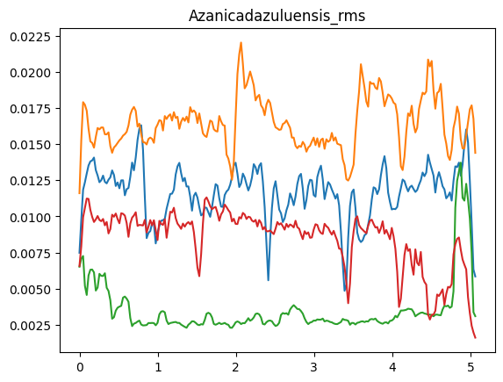
Figure 8: Root mean square of 4 Azanicadazuluensis

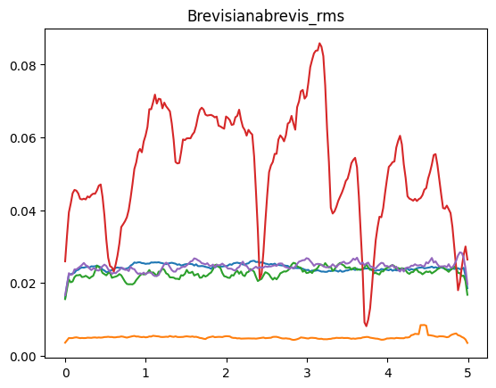
Figure 9: Root mean square of 5 Brevisianabrevis
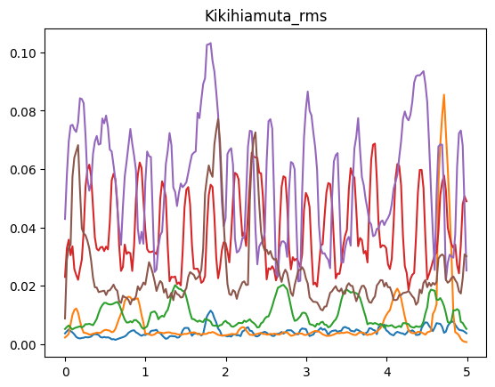
Figure 10: Root mean square of 6 Kikihiamuta
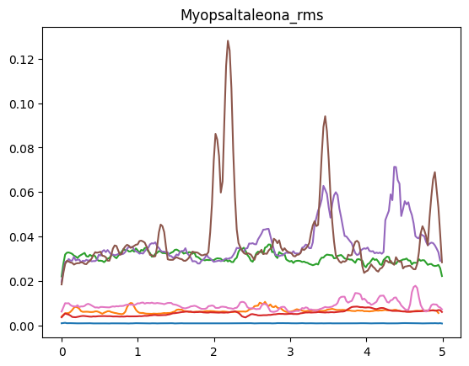
Figure 11: Root mean square of 7 Myopsaltaleona
AS we can see from the above given Plots, the RMS curves of the data were messy and hard to identify any particular pattern; therefore, pattern identification using RMS was also unsuccessful
- Zero Crossing Rate :
Here, we measured the number of times the signal crosses the horizontal axis by comparing 2 consecutive frames with their sample signal as input to the sign function (which returns +1,-1, or 0 if the signal is positive, negative, or Null, respectively). And subtracting and taking their absolute values of these values will result in 0 (if both the frames are in the same quadrant or Null ) or 2 (if both the frames have alternating signal position in it), which will be counted as 1 crossing. therefore, we divided it by 2, but we also have to normalize it, so we divided it by 2* No of samples in the frame or the frame size.

Mathematically:
ZCR = $\frac{1}{2N}\sum_{k=0}^{N-1}{\left|sgn\left(s(\left[k+1\right]\right)-sgn\left(s\left[k\right]\right)\right|}$
Where:
- N = Frame size/no of samples in the frame
- sgn = the sign function
- s(k) = kth sample inside the frame
Or in our case:
ZCR = $\frac{1}{2048}\sum_{k=0}^{1023}{\left|sgn\left(s(\left[k+1\right]\right)-sgn\left(s\left[k\right]\right)\right|}$

The code segment below shows how we calculate the amplitude envelope for all the species. Using the Librosa Package. (The dictionary audio_data has the loaded audio data with the species name as its Key)
#zero crossing rate
audio_envelop_single_species={}

for index,i in enumerate(audio_data.keys()):
audio=[]
for j in audio_data[i]:
y=librosa.feature.zero_crossing_rate(y=j)
audio.append(y)
audio_envelop_single_species[i]=audio

for index,i in enumerate(audio_envelop_single_species.keys()):
for j in audio_envelop_single_species[i]:
j=j.flatten()
t=librosa.core.frames_to_time(range(len(j)),hop_length=512)
plt.plot(t,j)
plt.title("Species_name_zero crossing")

Results:
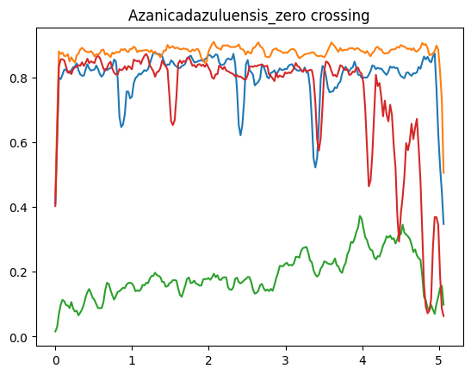
Figure 12: Zero crossing rate of 4 Azanicadazulensis
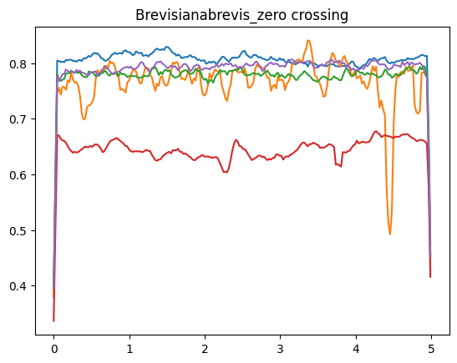
Figure 13: Zero crossing rate of 5 Brevisianabrevis
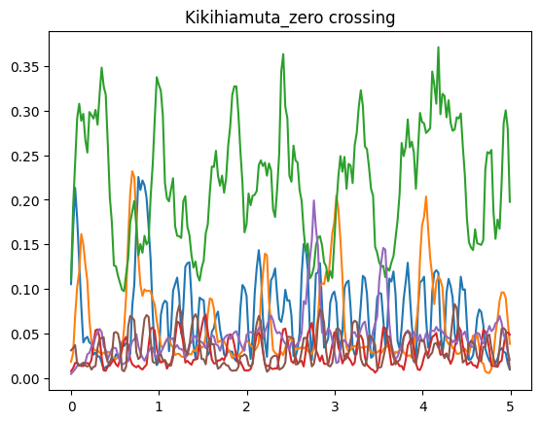
Figure 14: Zero crossing rate of 6 Kikihiamuta
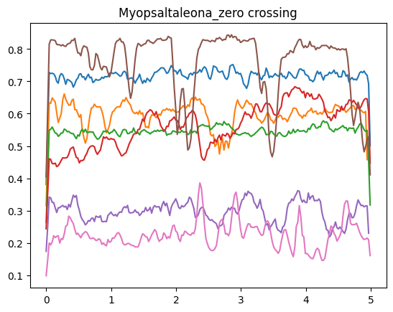
Figure 15: Zero crossing rate of 7 Myopsaltaleona
AS we can see from the above given Plots, the zero-crossing rates of the data were uneven and hard to identify any particular pattern; therefore, pattern identification using ZCR was also unsuccessful
Therefore,
THE STATUS OF PHASE 1 WAS UNSUCCESSFUL IN TERMS OF PATTERN IDENTIFICATION UPTO A RESONABLE STANDARD OF ACCURACY.

Phase 2 (Frequency-Domain)
Methods Used: Fourier Transform
Fourier Transform [Discrete]
The Fourier Transform is a mathematical tool that breaks down a complex signal (like a sound wave) into the simple, individual sine and cosine waves that make it up.
Mathematically
X[k]=$\sum_{n=0}^{N-1}{x\left[n\right]e^{-i2π\frac{kn}{N}}}$
Where
- x[n]= nth sample
- X[k]= kth frequency bin
- N= number of samples in the frame

The code segment below shows how we calculated the Fourier Transform for all the species. Using the Librosa Package. (The dictionary audio_data has the loaded audio data with the species name as its Key)
fourier transform

def fourrier(signal,frame_ratio,count):
fft=np.fft.fft(signal)
magnitude=np.abs(fft)
frequency=np.linspace(0,sr/2,len(magnitude))
frequency_bin=int(len(frequency)*frame_ratio)
plt.plot(frequency[:frequency_bin],magnitude[:frequency_bin])
plt.title(f"audio of Platypleuracapensis{index}")
plt.show()

for species_audio_list in audio_data.values():
for index,audio_signal in enumerate(species_audio_list):
fourrier(audio_signal, .5, index)

Results:

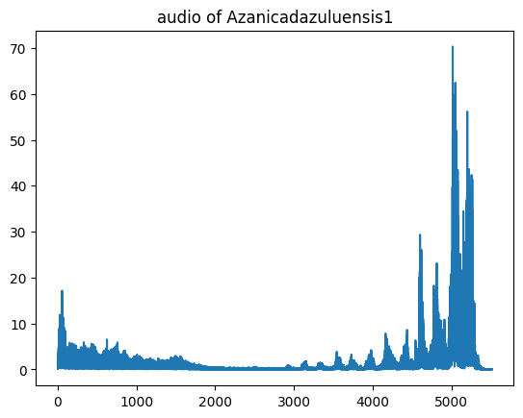
Figure 16: Fourier Transform of Azanicadazuluensis
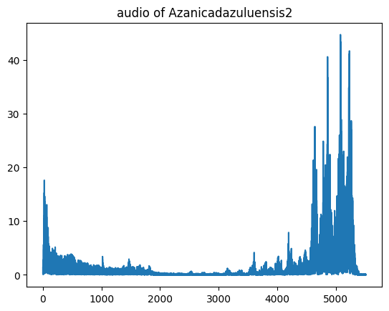
Figure 17: Fourier Transform of Azanicadazuluensis

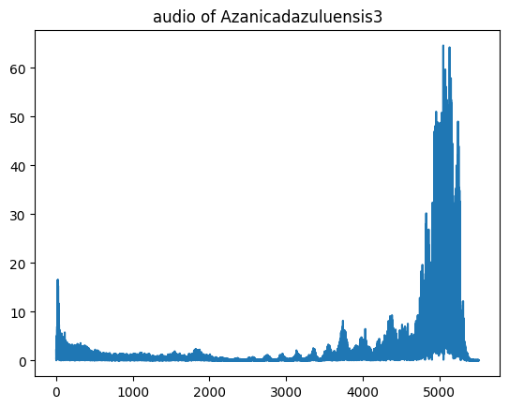
Figure 18: Fourier Transform of Azanicadazuluensis

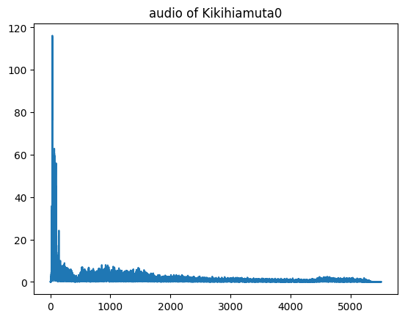
Figure 19: Fourier Transform of Kikihiamuta

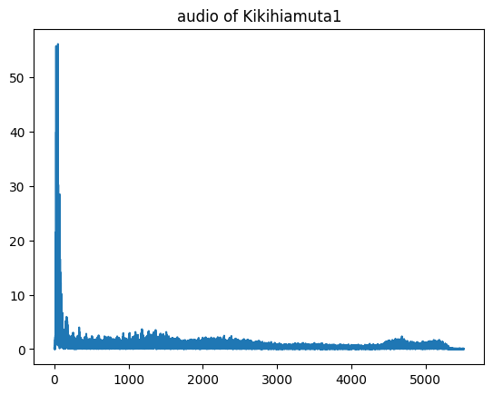
Figure 20: Fourier Transform of Kikihiamuta
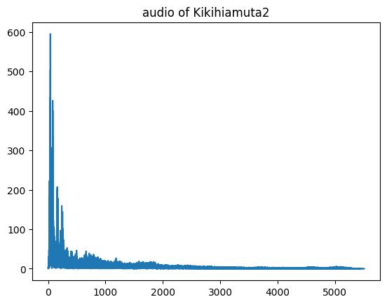
Figure 21: Fourier Transform of Kikihiamuta

Therefore, we see a pattern in the range of frequencies between individual species example from the figure 17 -19 for the species Azanicadazuluensis the typical peak magnitude is between the frequency 4.2khz to 5.8khz.
And from the figure 20- 22 for the species Kikihiamuta the typical peak magnitude is between the frequency 0 to 0.5khz.
This is taken as 1 parameter for the prediction model.

Phase 3 (Time Frequency-Domain)
Methods used: Short-time Fourier transform, mel-spectograms
1. Short-Time Fourier Transform[Discreate]
The Short-Time Fourier Transform (STFT) is a method to analyze how the frequency content of a signal changes over time. Fourier Transform gives us frequency info but it destroys time information.
STFT fixes that by:
- Cutting the signal into small frames using a window function (Hann's Windowing function is used here)
- Applying the Fourier Transform to each frame.
- Combining them to form a time-frequency representation
Mathematically
X(m,k)=$\sum_{n=0}^{N-1}{x\left[n+mH\right]w[n]e^{-i2π\frac{kn}{n}}}$
Where
- m = frame index
- k=frequency bin
- H=hop size
- N=window length
The code segment below shows how we calculated the Short Time Fourier Transform for all the species. Using the Librosa Package. (The dictionary audio_data has the loaded audio data with the species name as its Key)
#SHORT TIME FOURIER TRANSFORM

def stf(data,Frame,HOP,sr,i):
y=librosa.stft(data)
y_db = librosa.amplitude_to_db(np.abs(y), ref=np.max)

librosa.display.specshow(y_db,sr=sr,hop_length=HOP,x_axis="time",y_axis="linear")
plt.savefig(f"Species_Name{i}.png")

plt.colorbar(format='%+2.0f dB')
plt.show()

numofrange=len(audio_data["Species_Name"])
for i in range(numofrange):
stf(np.array(audio_data["Species_Name"][i]),2048,512,22050,i)

RESULTS
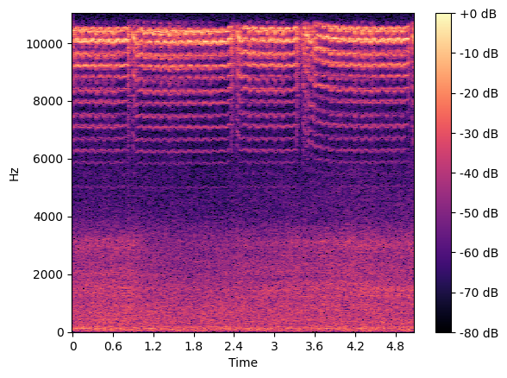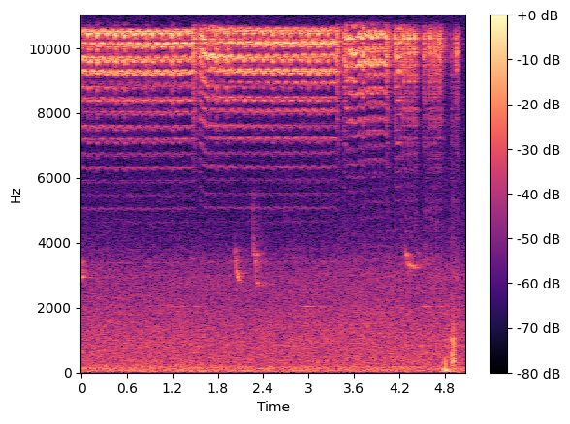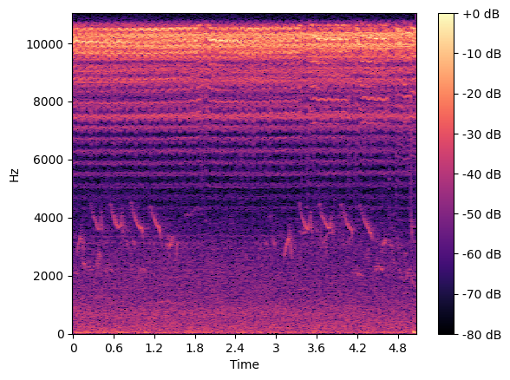
The above Spectograms of Azanicadazuluensis are showing a strong, High-Frequency Harmonics (~7 – 11 kHz) and repeating bursts of these harmonics.

A similar kind of observation, when done for other species, almost all species showed an individual pattern, which was also taken as a parameter.please refer the attached file for more results.

2. Mel-Spectrogram
A Mel spectrogram is a time–frequency representation where the frequency axis is warped into the Mel scale, a perceptual scale that compresses high frequencies and stretches low frequencies so it matches human hearing. It’s basically: compute a spectrogram, pass it through a Mel filterbank, then usually take the log (or dB).

The code segment below shows how we calculated the Mel-Spectrogram for all the species. Using the Librosa Package. (The dictionary audio_data has the loaded audio data with the species name as its Key).

#mel spectogram
def mel(y):
mel=librosa.feature.melspectrogram(y=y,sr=22050,n_fft=2048,n_mels=128)
db=librosa.power_to_db(mel,ref=np.max)
plt.figure(figsize=(10,5))
librosa.display.specshow(db,sr=22050,hop_length=512,x_axis="time",y_axis="mel")
plt.colorbar(format="%+2.0f dB")
plt.show()

for i in range(no_files):
mel(audio_data["Species_Name"][i])

Results:
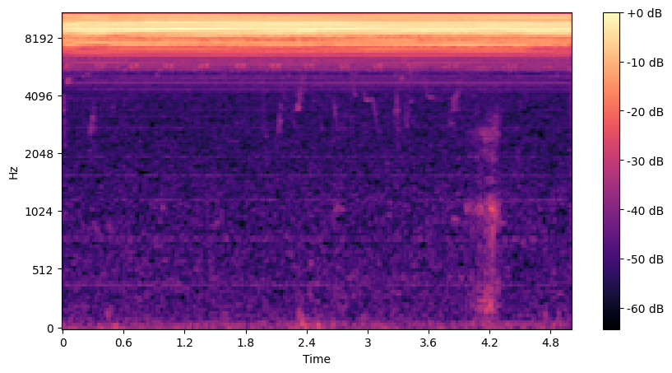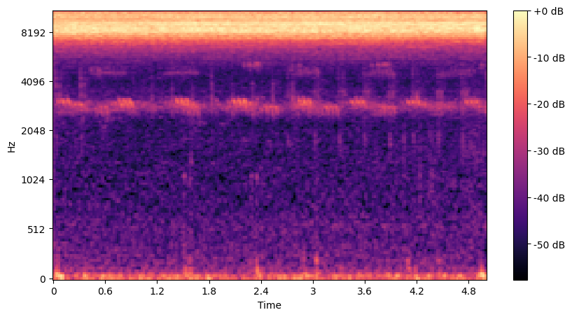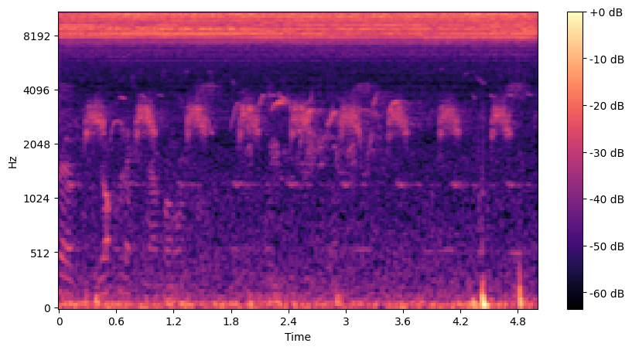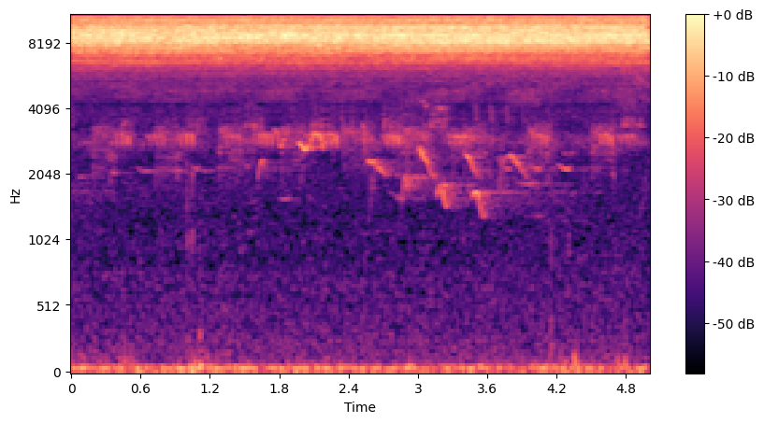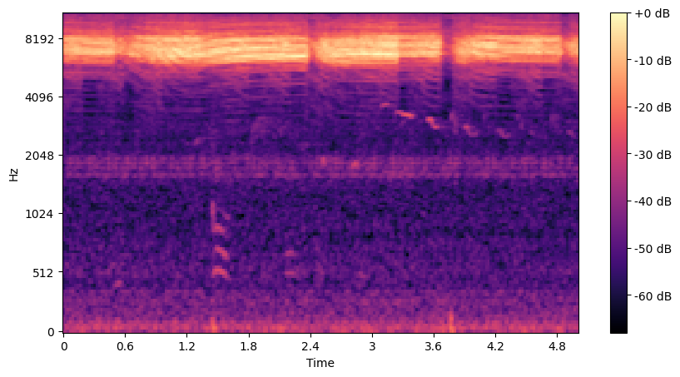

The above pictures are the Mel-Spectrogram of the species Brevisianabrevis.
From this we can observe

1. Dominant high-frequency tone (7.5–9.5 kHz)
— most stable and bright feature
— the species’s main acoustic marker

2. Secondary band around 3.5–4.5 kHz
— weaker but consistent in multiple samples

3. Vertical transient bursts (1–4 kHz)
— irregular, click-like short sounds
— helps differentiate species

4. Repetitive time blocks
— signal appears in rhythmic sections, not random scatter
Together, these form a robust species-level identification fingerprint.Hence this was also taken as a variable in the classification model.

